# Exercise 1a – Setting up your Jupyter Notebook working folder

# Description

When you first run the Jupyter Notebook application via Anaconda you might notice that you get a looooot of stuff that appears on the frontpage. This is because the default location of Jupyter is placed together with the Anaconda installation, this is why all those folders appear on the startup page.

In this exercise we are going to set a better startup directory for Jupyter notebook. This means that the next time you start Jupyter you should see a lot less clutter.

## Needed Setup

* Working installation of Anaconda (for an installation guide checkout the Anaconda installation Guide document)

>>> Continues on the next page

## Part 1/1

First, we will start by setting the standard startup page for Jupyter Notebook to a new directory we will use for the course.

* Create a new folder called Jupyter Notebook Proj, preferably somewhere easily reached. I created mine on the desktop
* In the searchbar of your computer, search for Anaconda Prompt and launch it. 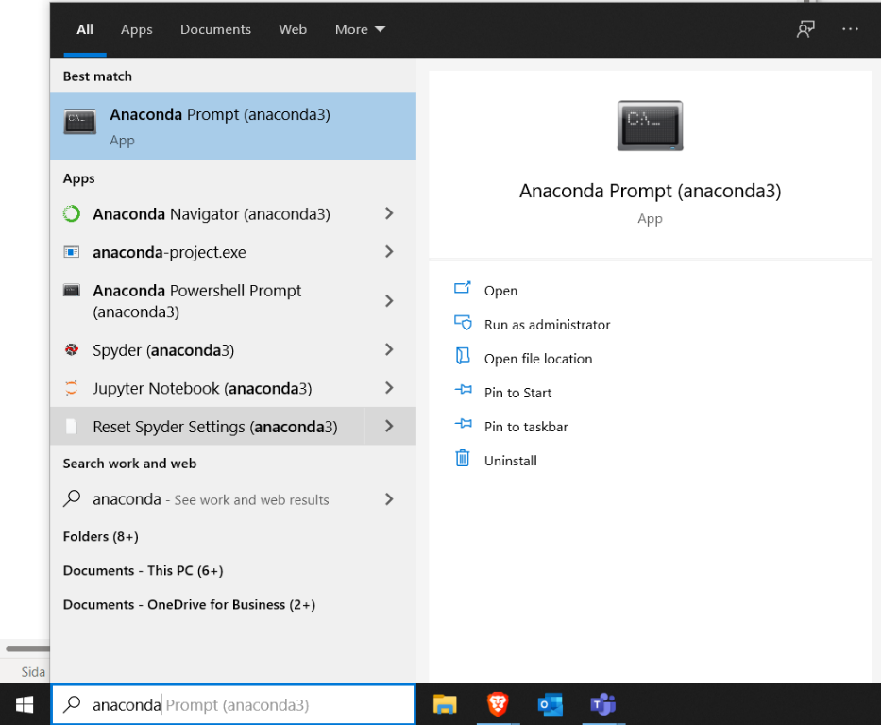
* Type jupyter notebook --generate-config and hit enter. You will now see a file path generated, copy this path
* Paste the path into the file explorer 
* The config file will now be opened, if you have to choose a program to open the file with pick a text editor like notepad. Anything that is a text editor works just fine
* In the file search for # c.NotebookApp.notebook_dir=’’

(note you might not find it sometimes, try searching for parts of the word)

* Remove the # and inside the ‘ ‘ put the path to your Jupyter Notebook Proj folder we created. Make sure to replace all the backslashes \ with forward slashes /
* Run Jupyter notebook again and you should see a much cleaner startupfolder:)
* On my computer with windows 10 it looks something like this (I have created a folder called Py2B already, your window should be empty)

